Title: DAQ V1.0 Software Bring Up
Project: Hybrid Sky Data Capture System, Version 1.0
Date: March 23, 2009
Author: Stephen Daniel
1. Introduction
Initializing a new system requires a number of steps. This is complex because the DAQ system is designed to load firmware off its internal memory. But how does firmware get onto the internal memory in the first place.
This document provides the step-by-step to getting the memory formatted, firmware loaded, and the PIC’s configuration EPROM properly set up.
2. Programming the Chip
This first step is to get the USB boot-loader programmed onto the PIC. Using a PIC programmer (such as the PIC-Start), program the PIC using the USB Boot firmware. For reference, configuration bits should look like this:
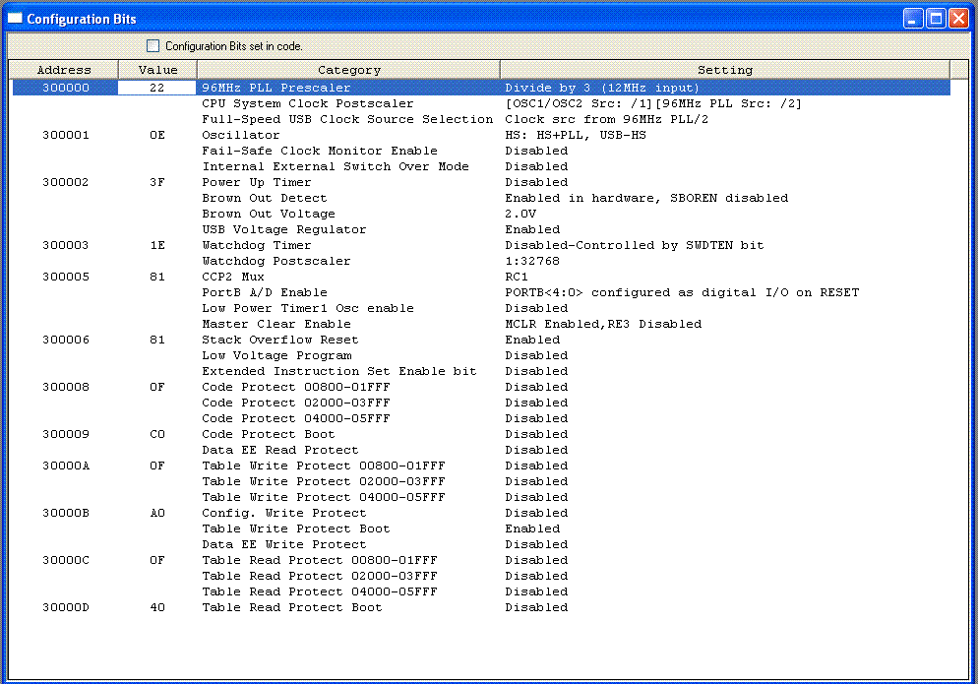
3. Formatting the Memory Card
Install the programmed PIC in the DAQ system. Connect the DAQ system to the computer via the USB.
Set the mode knob to 0 (all the way counter-clockwise.
Power up the board.
Launch the program PDFSUSB on the computer. Use it to download the program usbdrive.hex into the DAQ.
Set the knob to position 1.
Power cycle the board.
Open a DOS window. Run:
format e: /FS:FAT /Q /V:DAQ /A:1024
4. Loading Firmware
In the install directory, run “make”, then “make install”. This should copy the files into the DAQ card.
5. Programming the EPROM
Use PDFSUSB to load the program mode2com.hex into the DAQ system.
Program in the file names of the firmware and the data file.
M,1,MODE1.DAQ
M,2,MODE2.DAQ
M,3,MODE3.DAQ
M,4,MODE4.DAQ
M,8,DATA
6. Final Programming
Use PDFSUSB to load the program boot2.hex into the DAQ system.
7. Formatting the Data file.
The DAQ board records data into a pre-existing file. Create that file:
dd if=/dev/zero of=/cygdrive/e/DATA bs=1024 count=7168
8. Starting the TOD Clock
Bring up the board in serial console mode (mode 2).
Use the y, m, h, and s commands to set the clock and start it running. The clock’s main backup supply capacitor does not start charging until the ‘s’ command is entered.
.

